Christopher Wilson
8/26/2026
CS-660 Module Eight Assignment

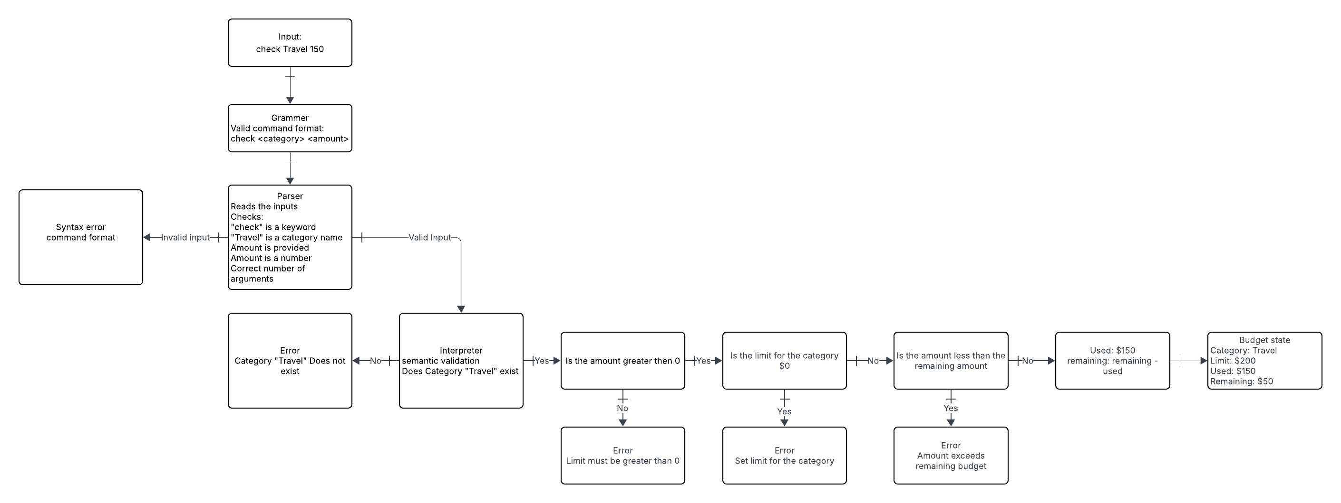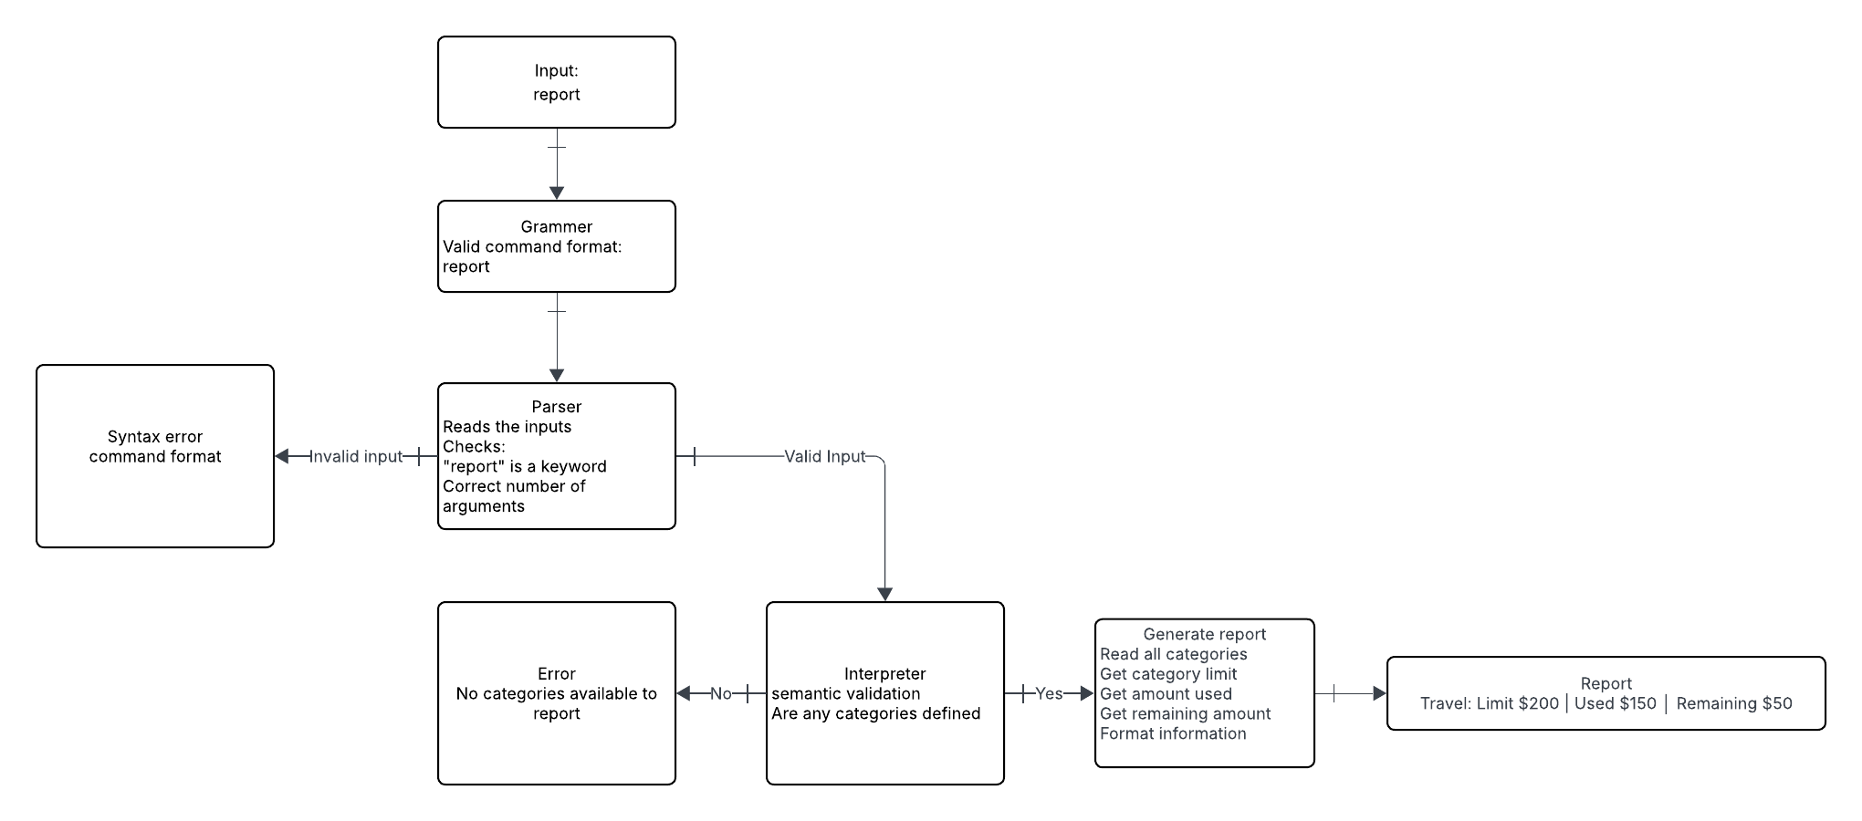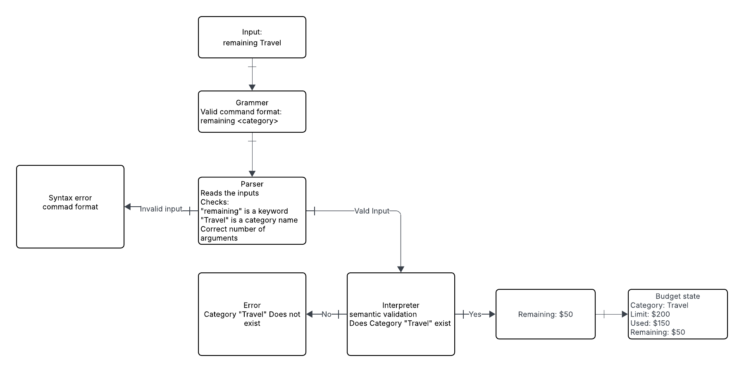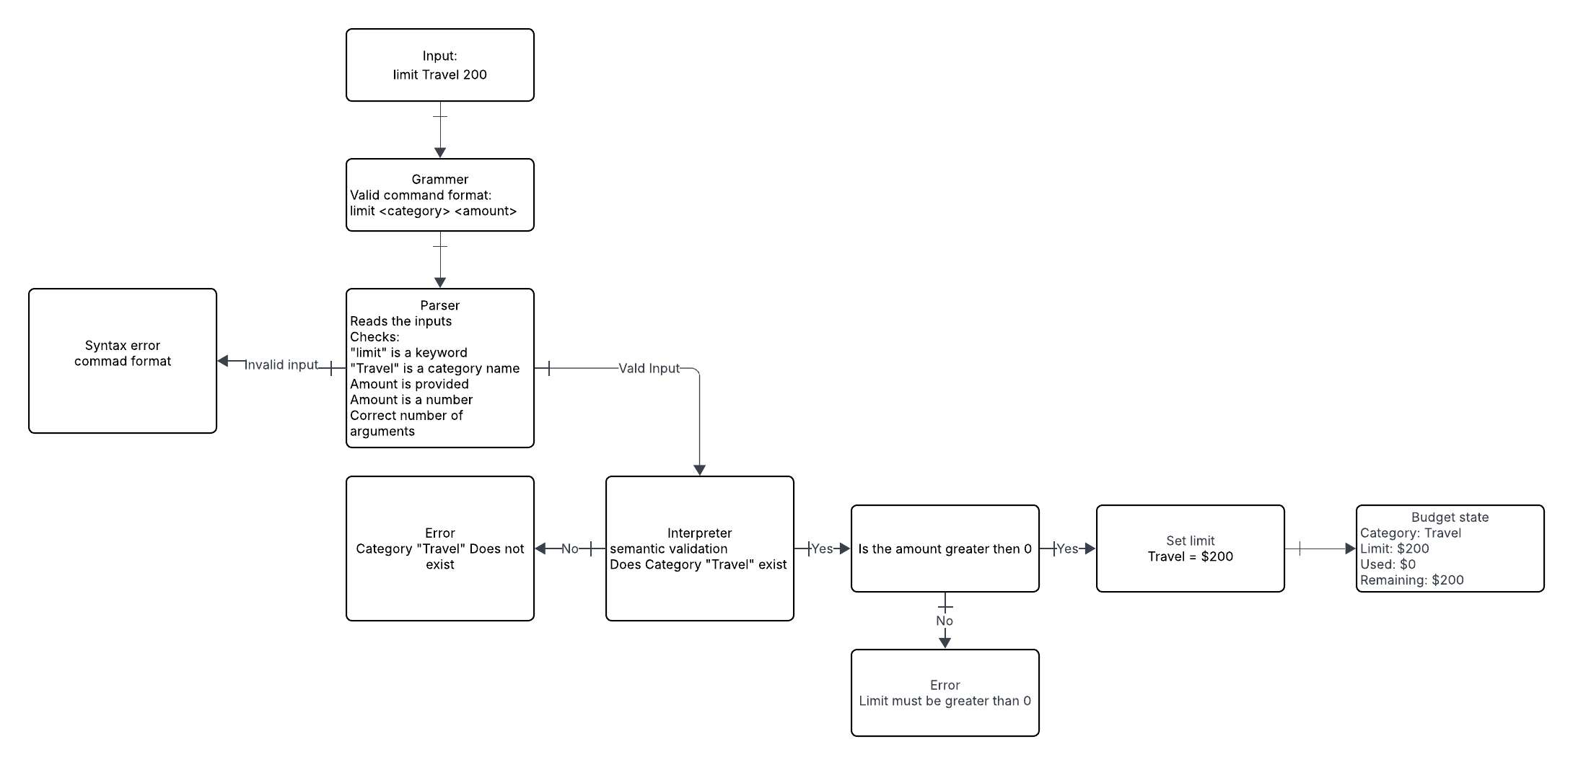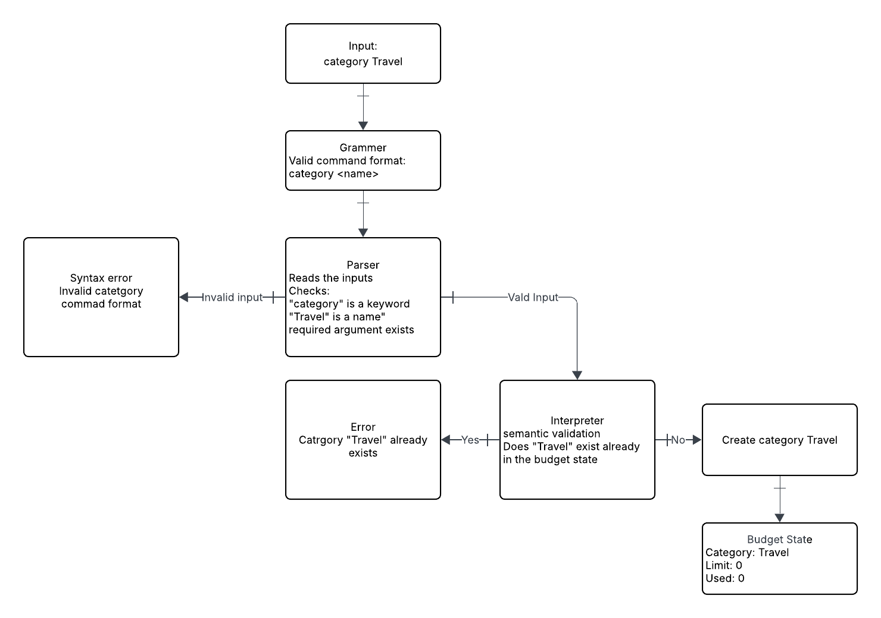
Design tradeoff
One trade-off my DSL has is between flexibility and safety. The DSL only supports a small number of commands, which makes it less flexible. However, limiting the commands makes the DSL safer because it reduces the chance of users entering invalid or unintended operations.
1. Describe the structure of your DSL system and how the components work together.
My DSL system uses a grammar, parser, and interpreter. The grammar defines the rules for the five commands: category, limit, check, remaining, and report. The parser reads each command and checks its syntax to make sure it follows the grammar, such as making sure a limit contains a valid category and number. If the command is valid, the interpreter executes it and handles the semantic processing, such as creating a category, setting a budget limit, checking an expense, showing the remaining budget, or generating a report. The components work together by taking the user's input, checking that it is valid, and then executing the command to produce the correct result.
2. Explain how syntax and semantics are handled in your language.
In my DSL, syntax is handled by the parser. The parser checks that each command follows the correct structure and uses valid values. For example, limit Travel 200 has the correct command, category, and number. Semantics are handled by the interpreter after the syntax is valid. The interpreter determines what the command means and performs the appropriate action, such as setting the Travel budget to $200 or checking if an expense is within the remaining budget. The interpreter also handles semantic errors, such as an invalid value or a value that violates a budget rule. For example, if a user enters a negative expense or tries to set a negative budget limit, the interpreter would reject the value and display an error message.
3. Describe the rationale for your tradeoffs in safety, flexibility, or expressiveness.
I chose to prioritize safety and simplicity over flexibility in my DSL. The language only has a small number of commands, which limits what users can do compared to a general-purpose language. However, this makes the DSL easier for non-programmers to understand and reduces the chance of users entering commands that could cause incorrect budget information. The parser can also reject invalid commands and values before they reach the interpreter, which adds another layer of safety. I think this tradeoff is appropriate because the DSL is designed for one specific task, which is validating expenses against a business budget policy.
4. Evaluate how your diagram communicates the architecture and control flow of your DSL.
My diagram communicates the architecture and control flow of my DSL by showing how a command moves through each part of the system. The diagram starts with the DSL input and uses arrows to show how the input moves through the grammar, parser, and interpreter before showing an output. It also labels the parser as handling syntax and the interpreter as handling semantic processing, which shows what each component does. The diagram makes the process easy to understand because each component has a specific purpose, and the arrows clearly show the order in which the command is processed.

